Create AWS Ubuntu Instance

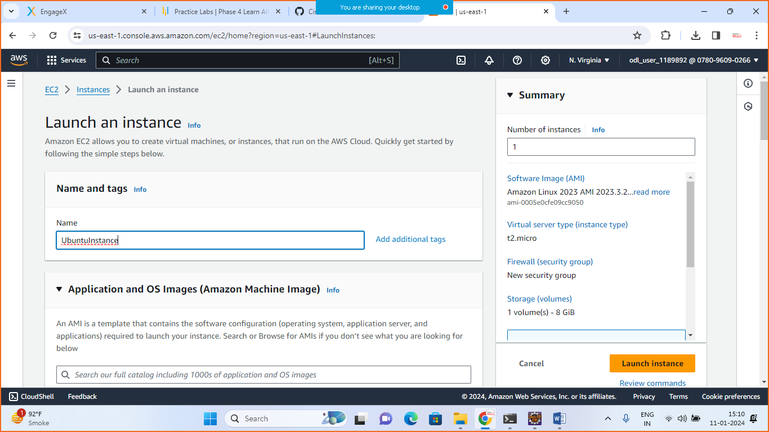

Choose operating system

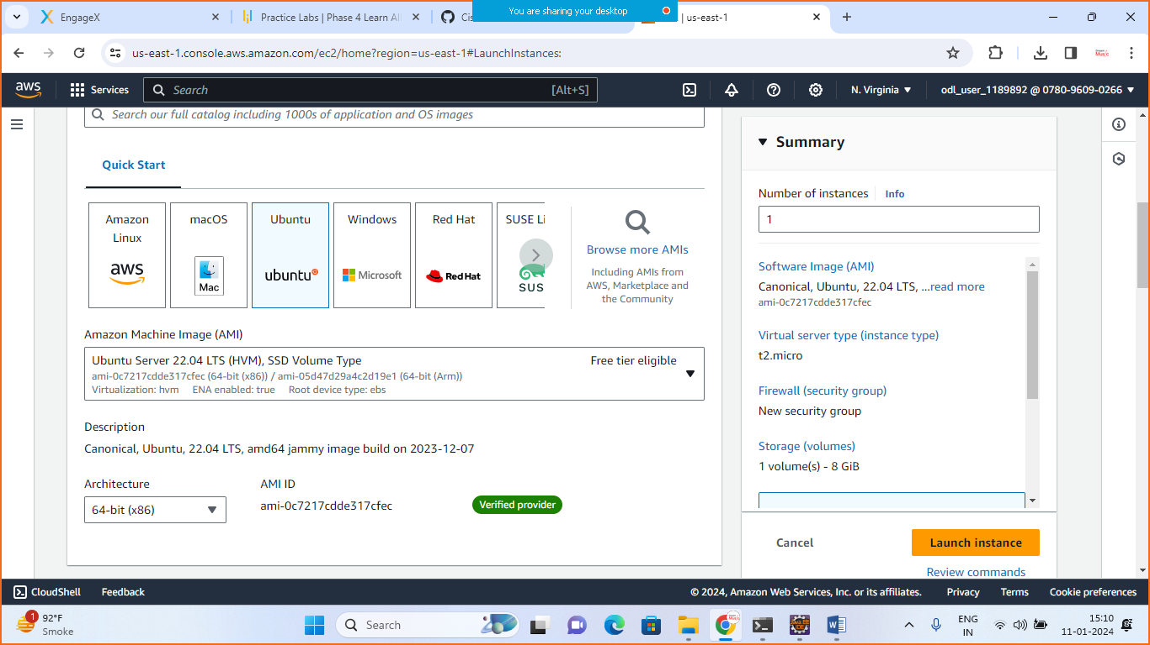

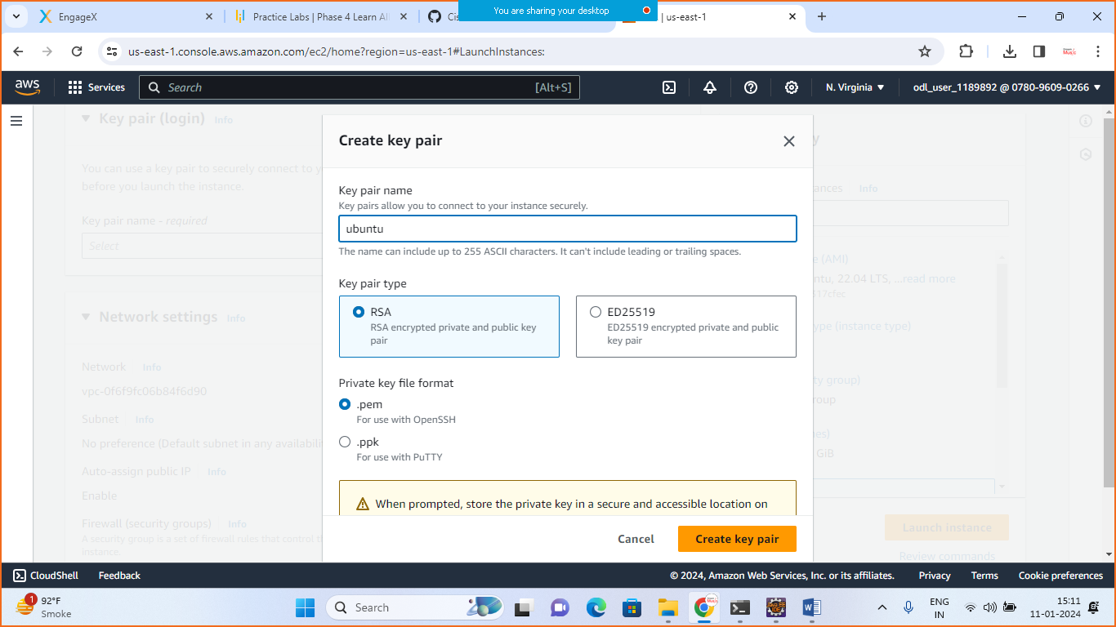

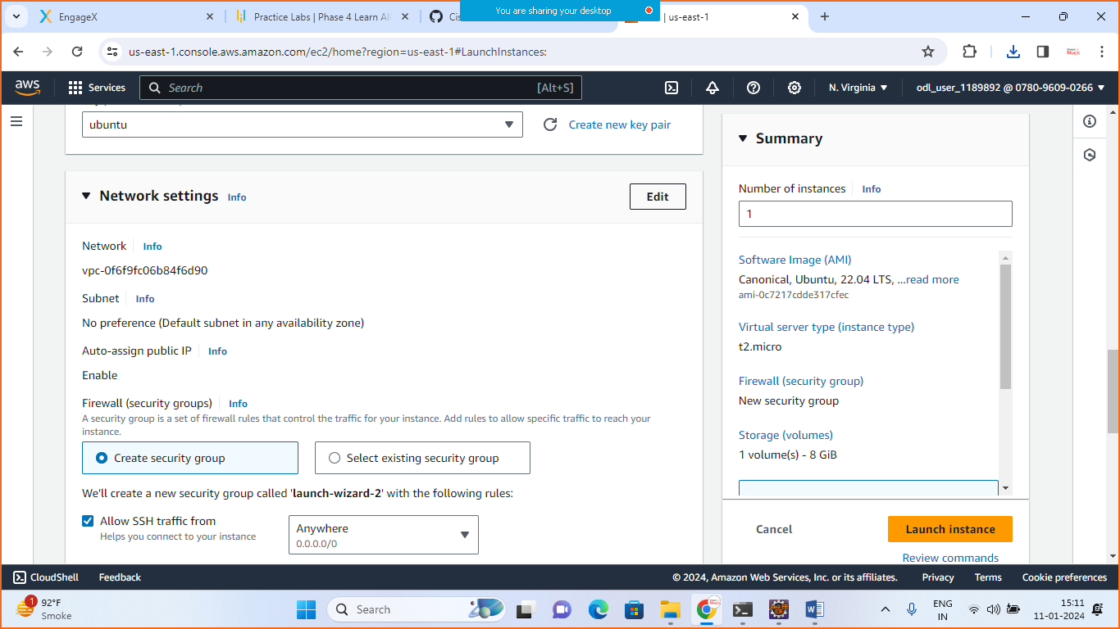

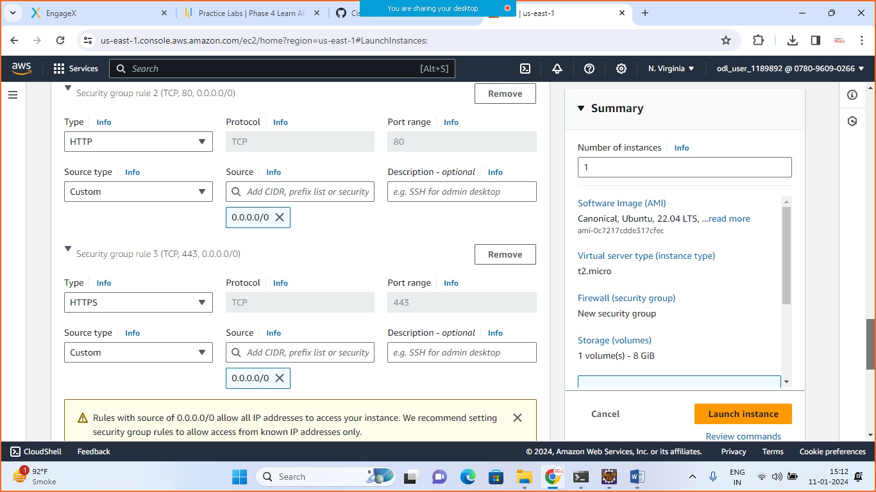

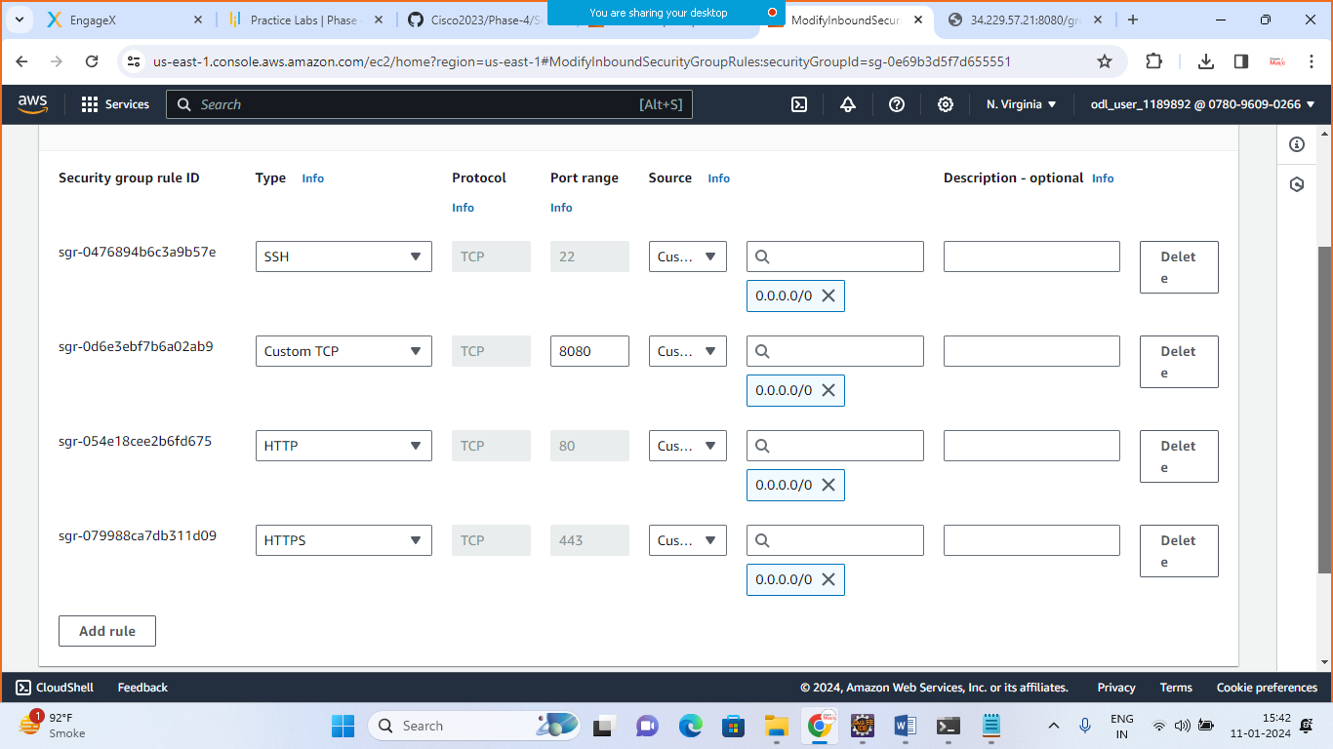

Open cmd > move to the root folder >

Paste the key and hit enter

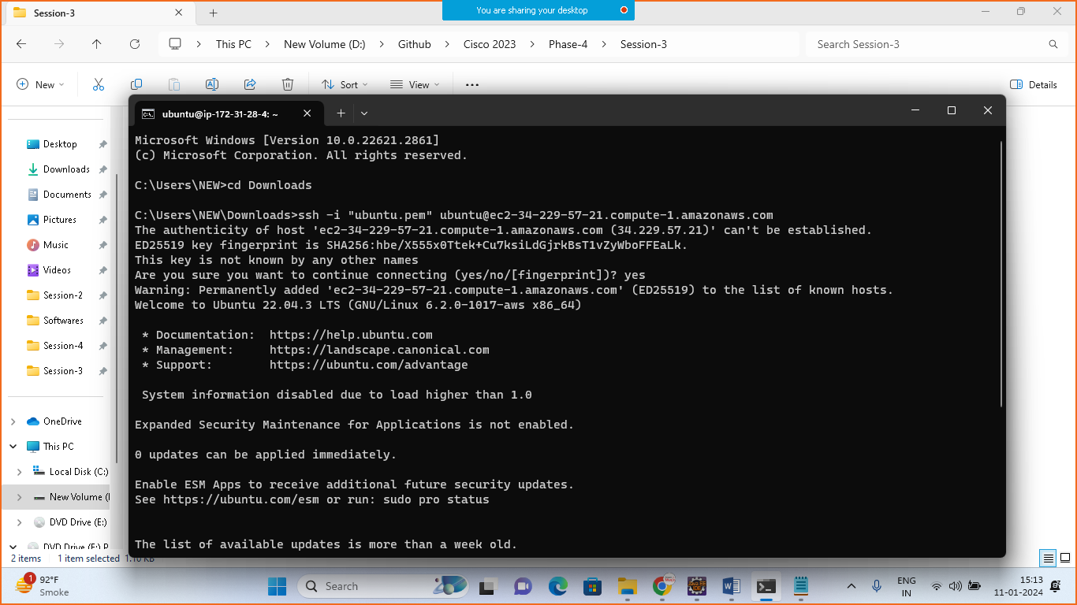

Note: for connecting with AWS EC2 instance need to add accesskey and security key that we have already added in previous example

install java

--------------------

> sudo apt update

> sudo apt install openjdk-17-jdk openjdk-17-jre

> java -version

install maven

-------------------

> sudo apt update

> sudo apt-get install maven

Create Directory in AWS and copy your jar file there

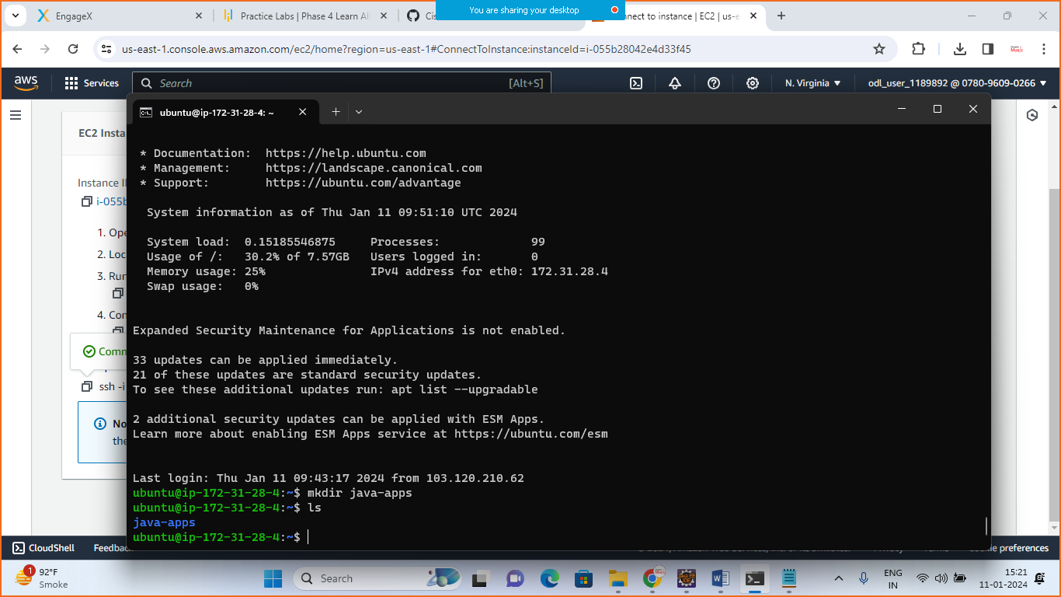

* mkdir java-apps
* ls

and see the directory prepared

* do the logout

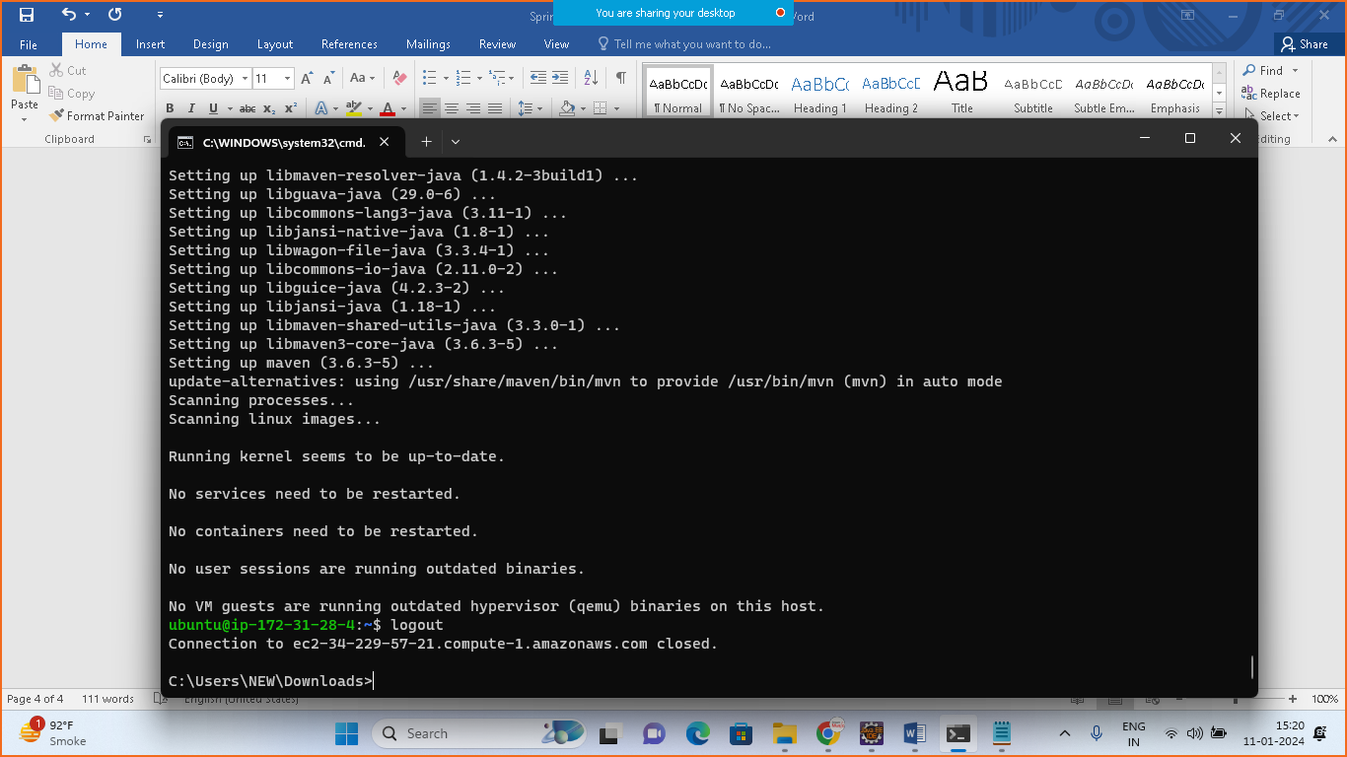

Now upload your app

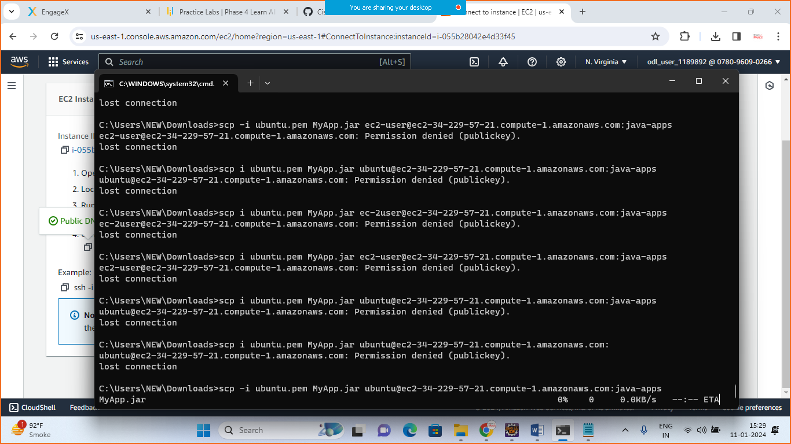

1. ubuntu.pem == my Key
2. MyApp.jar==Springboot Jar File
3. Ubuntu==name of my instance
4. Java-apps==Directory in AWS

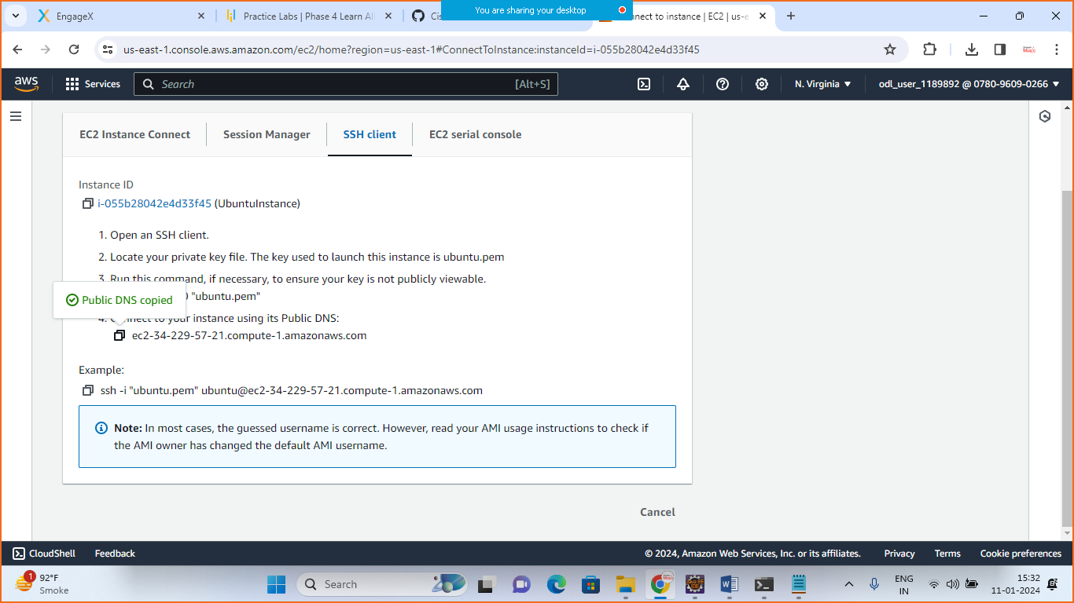

Connect the instance

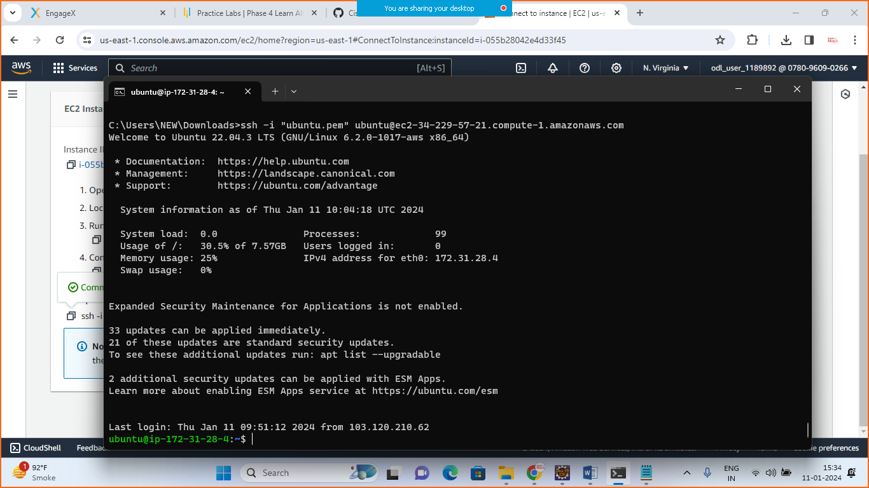

Run Your Applcation

Move to the java-app folder

* cd java-apps
* ls

this will show us the uploaded jar file

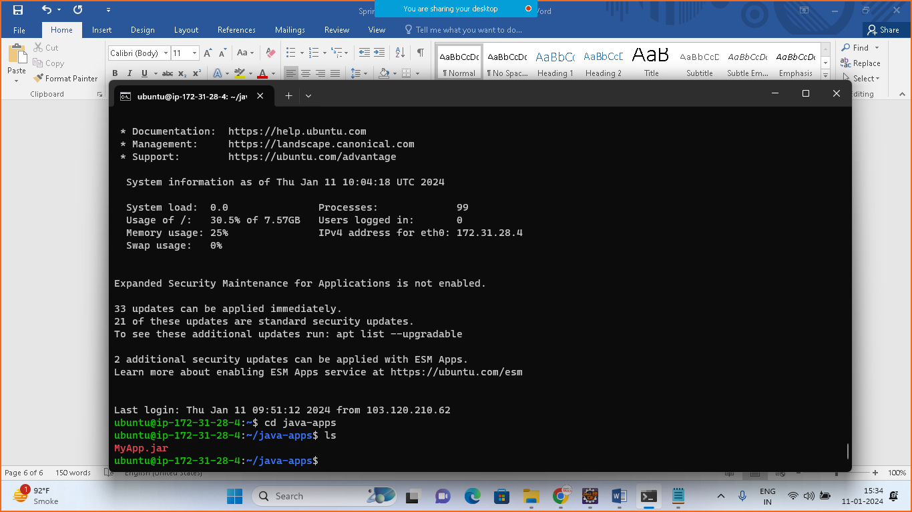

> java -jar MyApp.jar

Change the security port no to 8080

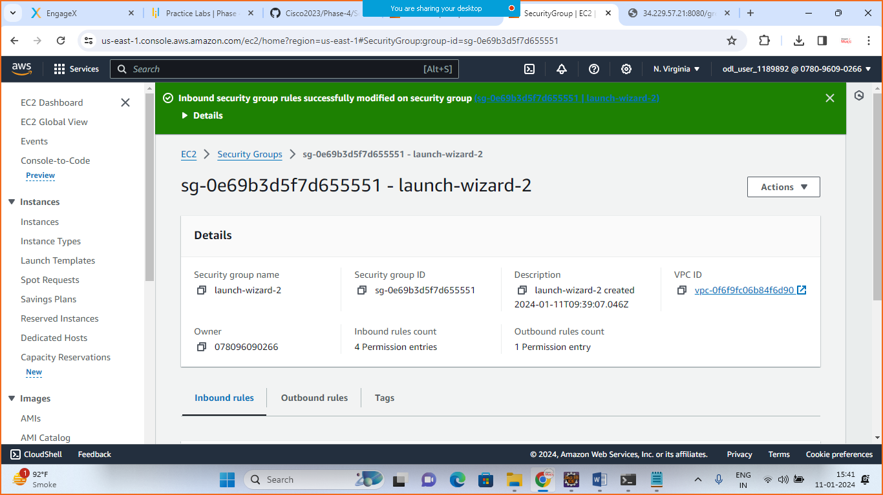



------------------

>once tomcat is started goto>AWSinstance>click on it>copy Public IPV4 address:8080/greet/Welcome to AWS

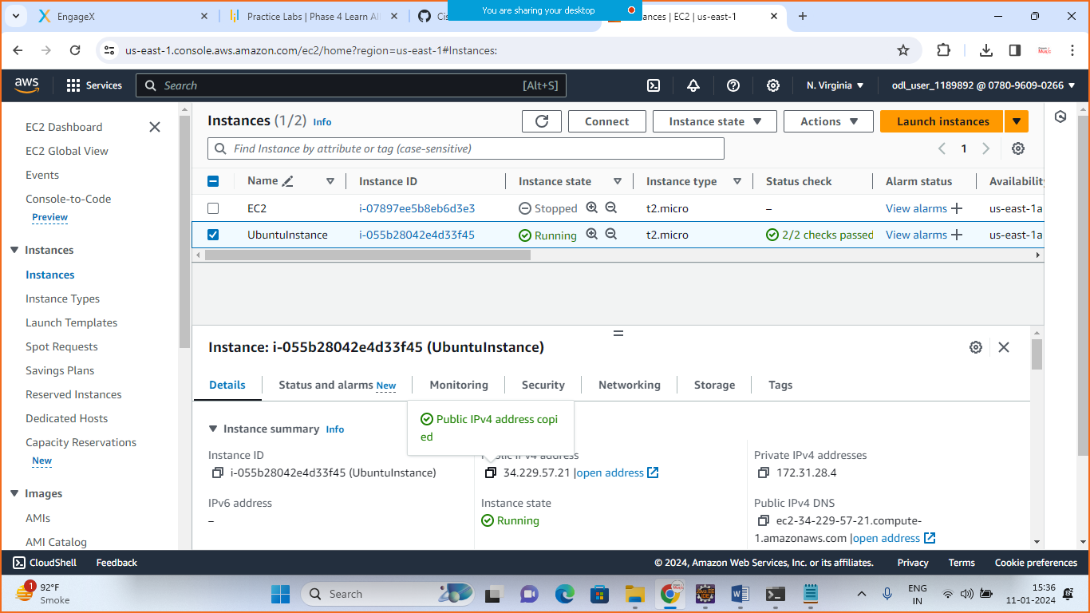

> you will see the output

Ipaddress:8080

